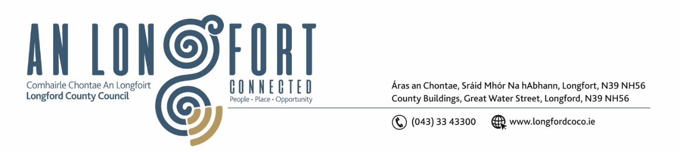

**LONGFORD MUNICIPAL DISTRICT**

***Please note meeting will be held in the Council Chamber, Aras an Chontae and via Microsoft Teams***

**20 June 2023**

**To: Each Member of Longford Municipal District.**

**Dear Member,**

You are requested to attend the Meeting of Longford Municipal District to be held in **the Council Chamber, Aras an Chontae** and **via Microsoft Teams** on **Wednesday 28 June 2023 at 3.30pm** to transact business, as set out on the agenda hereunder.

**Yours sincerely**,

_______________

**Claire McNabola**

**Meetings Administrator**

**AGENDA**

Prayer before meeting.

**1.** Confirmation of Minutes:

1. Longford Municipal District Meeting held on Wednesday 24 May 2023 – enclosed.
2. Longford Municipal District Committee Meeting held on Wednesday 24 May 2023 – enclosed.

**2.** Matters arising from Minutes.

**3.** Declaration of Interest by Members.

**4.** Management Report – to follow.

**5.** Consideration of funding for Longford Summer Festival 2023

**6.** **Notices of Motions, submitted by Councillors, as listed hereunder –**

**Councillor Gerry Warnock**

I'm calling on Longford MD to install a Convex Safety Mirror at the junction at Annaly Park and Richmond Street (N5). Clear line of sight cannot be achieved on the righthand side when exiting Annaly Park due to a boundary wall, and this represents a potential road safety issue.

**Councillor Peggy Nolan**

I wish to ask this Council to put line markings and signage in place with immediate effect at Legion Terrace, Longford.

This one time cul-de-sac is now facilitating two housing developments with construction ongoing to deliver much needed housing. The current volume of traffic in this area needs assessing, and funding made available to address the dangerous situation that is causing great concern to the residents health and safety. At this stage, it needs to be addressed.